**DESIGN AND IMPLEMENTATION OF AN ORDER REVIEW E-COMMERCE**

**BY**

**OKEREKE,** CHIMEMEZIEM DANIEL

BU/23A/IT/8106

DEPARTMENT OF INFORMATION SYSTEMS MANAGEMENT

BAZE UNIVERSITY

ABUJA

**SEPTEMBER, 2025.**

**Design And Implementation Of An Order Review E-Commerce**

**Project Submitted in Partial Fulfillment of the Requirements for the Degree of**

**B. Sc.**

**In**

**Information Systems Management**

**By**

**Okereke,** Chimemeziem Daniel

To

The Department of Information Systems Management

Baze University, Abuja

**September, 2025.**

# DECLARATION

I hereby declare that this project, entitled “**Design and Implementation of an Order Review E-Commerce,**”was carried out by me under the supervision of Dr. Usman Bello Abubakar. The work has not been presented in any previous work for the award of a BSc degree to the best of my knowledge. The work is entirely mine and I accept the sole responsibility for any error that might be found in the work, while the reference to published material has been duly acknowledged.

__________________________ _____________________

Okereke Chimemeziem Daniel Date

BU/23A/IT/8106

**APPROVED BY**

_____________________

**Head of Department,**

Department of Computer Science

# CERTIFICATION

This is to certify that this project entitled “**Design And Implementation of an Order Review E-Commerce”**, being submitted by Okereke, Chimemeziem Daniel in partial fulfilment of the requirement for the award of degree for B.Sc. in Information Systems Management to the Department of Computer Science, Baze University Abuja, Nigeria is a record of the candidate’s own work carried out by the candidate under my supervision. The matter embodied in this project is original and has not been submitted for the award of any other degree.

__________________________ _____________________

Date Dr Usman Bello Abubakar

# APPROVAL

This is to certify that this project entitled, **Design and Implementation of an Order Review E-Commerce** by **Okereke Chimemeziem Daniel** with BU/23A/IT/8106 has been approved by the Department of Computer Science, Faculty of Computing and Applied Science, Baze University, Abuja, Nigeria.

By

_____________________ _____________________

Dr Usman Bello Abubakar Date

Supervisor

_____________________ _____________________

Dr Usman Idris Abubakar Date

Head of Department

_____________________ _____________________

Prof. Rufai Aliyu Yauri Date

Dean, Faculty of Computing and Applied Science

_____________________ _____________________

Date

External Examiner

# DEDICATION

I dedicate this work to my family and friends for their constant support. To the faculty staff of Information Technology, Dr Usman Bello Abubakar, Dr Abubakar Idris Usman, Mr. Tijanni Abdullahi, Prof. Peter Ogedebe, Dr Noah Akande, Dr Charles Isah Saidu, to name a few. This project is a testament to their unwavering support, guidance, and wisdom. Lastly, to all fellow enthusiasts who believe technology can be used to improve human lives.

# ACKNOWLEDGMENT

Allow me to sincerely thank and appreciate my parents and siblings for their never-ending love and support. They have been an invaluable asset throughout this journey. To my supervisor and mentors, a heartfelt gratitude goes to you for your guidance, insight, and encouragement. Without you all I would not have come this far. Lastly, I would like to acknowledge my friends and colleagues for their support and encouragement throughout my academic journey.

Thank you all.

# ABSTRACT

This project introduces an Order Review E-Commerce System tailored for cash-reliant markets like Nigeria, tackling trust issues and inefficiencies in online shopping. Built using an Agile approach, the system employs PHP with Laravel for robust backend logic, React.js for a sleek, user-friendly frontend, and SQLite for efficient data storage. The design follows a three-tier architecture, enabling seamless order review, real-time tracking, and automated verification processes. The resulting platform, "Subme," empowers customers to confirm or adjust orders before delivery, significantly reducing fraud and return rates. It streamlines backend operations by automating order checks, cutting down manual work for merchants. The system’s significance lies in boosting consumer confidence through transparent order management and optimizing logistics for Payment on Delivery (POD) transactions. It offers a practical blueprint for e-commerce in emerging markets where cash dominates. The project concludes that this solution effectively addresses trust and operational challenges, paving the way for scalable, localized e-commerce systems. Future enhancements, such as adding digital payment options and AI-driven fraud detection, could elevate its impact, making it a game-changer for online retail in Nigeria and beyond.

# TABLE OF CONTENTS

DECLARATION i

CERTIFICATION ii

APPROVAL iii

DEDICATION iv

ACKNOWLEDGMENT v

ABSTRACT vi

TABLE OF CONTENTS vii

LIST OF TABLES ix

LIST OF FIGURES x

CHAPTER 1 1

INTRODUCTION 1

1.1 Background of the Study 1

1.2 Statement of the Problem 1

1.3 Aim and Objectives 2

1.4 Significance of the Project 2

1.5 Scope and Limitation of the Study 3

1.6 Project Risks Assessment 3

1.7 Project Organization 4

1.8 Definition of Terms 4

CHAPTER 2 6

LITERATURE REVIEW 6

2.1 Introduction 6

2.2 Historical Overview 6

2.3 Benefits of Digitalization of Archives 7

2.4 Challenges of Digitalization of Archives 8

2.5 Barcode Scanner in Archival System 8

2.6 Related Work 9

2.6.1 Summary of Related Work 11

2.7 Summary 13

CHAPTER 3 14

REQUIREMENTS, ANALYSIS, AND DESIGN 14

3.1 Overview 14

3.2 Adopted Methodology 14

3.3 Tools and Techniques 15

3.4 Requirement Analysis 15

3.4.1 Software Requirements 15

3.4.2 Hardware Requirements 15

3.5 Requirements Specifications 15

3.5.1 Functional Requirements 15

3.5.2 Non-Functional Requirement Specifications 16

3.6 System Design 17

3.6.1 Application Architecture 17

3.6.2 Use Case Diagram 17

3.6.3 Entity Relationship Diagram 20

3.6.4 Activity Diagrams 21

3.6.5 Dataflow Diagram 23

3.6.6 Control Flow Diagram 23

3.6.7 User Interface Design Prototype 24

3.7 Summary 28

CHAPTER FOUR 29

IMPLEMENTATION AND TESTING 29

4.1 Overview 29

4.2 Main Features 29

4.3 Implementation Problems 30

4.4 Overcoming Implementation Problems 31

4.5 Testing 31

4.6 User Guide 36

4.7 User Interface Design 38

4.8 Summary 44

CHAPTER FIVE 45

DISCUSSION, CONCLUSION, AND RECOMMENDATIONS 45

5.1 Overview 45

5.2 Objectives Assessment 45

5.3 Limitations and challenges 45

5.4 Future Enhancements 46

REFERENCES 48

APPENDICES 49

# LIST OF TABLES

Table 1.1: Risks Assessment 3

Table 2.1: Summary of Related Work 10

Table 3.1: Functional Requirement Specifications 14

Table 3.2: Non-Functional Requirement Specifications 15

Table 3.3: Use-Case Description for Login/Register 17

Table 3.4: Use case Description for Admin 17

Table 3.5: Use Case Description for Document upload 18

Table 3.6: Use Case Description for View Document 18

Table 3.7: Use Case Description for Scanning. 18

Table 3.8: Use Case Description for Deleting 19

Table 4.1: Testing for Add User 31

Table 4.2: Testing for View Users 31

Table 4.3: Testing for Upload Documents 32

Table 4.4: Testing for View Document 32

Table 4.5: Testing for Document Scanning 33

Table 4.6: Testing for Login Page (Students) 33

Table 4.7: Testing for Register Page (Student) 34

Table 4.8: Testing for Logout 34

# LIST OF FIGURES

Figure 3.1: Agile Model 13

Figure 3.2: Application Architecture Diagram 16

Figure 3.3: Use Case Diagram 16

Figure 3.4: Entity Relationship Diagram 19

Figure 3.5: Login Activity Diagram 20

Figure 3.6:Document Upload Activity Diagram (for Student) 20

Figure 3.7:Manage Document Activity Diagram (for Admin) 20

Figure 3.8**:** View Document Activity Diagram (for Student and Admin) 21

Figure 3.9:Scan Document Barcode Activity Diagram 21

Figure 3.10:Manage User Activity Diagram (for Admin) 21

Figure 3.11:View User History Activity Diagram (for Admin) 21

Figure 3.11: Dataflow Diagram 22

Figure 3.12:Control Flow for Student 22

Figure 3.13:Control Flow for Admin 23

Figure 3.14:Home Page Prototype 23

Figure 3.15:Register Page Prototype 24

Figure 3.16:Login Page Prototype 24

Figure 3.17:Admin View Page Prototype 25

Figure 3.18:Add User Page Prototype 25

Figure 3.19:View Student Page Prototype 26

Figure 3.20:Upload Document Page Prototype 26

Figure 3.21:Scan Document Page Prototype 27

Figure 4.1: Home page 36

Figure 4.2: Register Page 37

Figure 4.3: Login page 37

Figure 4.4: View Admin Page 38

Figure 4.5: View Student Page 39

Figure 4.6: Upload Documents Page 39

Figure 4.7: Scan document page 40

Figure 4.8: Add User Page 40

Figure 4.9: User Dashboard Page 41

Figure 4.10: Category View Page 41

Figure 4.11: Category Action Page 42

# CHAPTER 1

# INTRODUCTION

## 1.1 Overview

Electronic commerce (e-commerce) revolutionizes global trade by enabling transactions over the internet, eliminating the need for physical interactions between buyers and sellers (Jain, 2021). With over 2.5 billion internet users globally, e-commerce platforms create dynamic marketplaces that connect consumers and merchants worldwide (Miniwatts Marketing Group, 2021). These platforms leverage digital technologies to offer convenience, speed, and access to a vast range of products (Rayport & Jaworski, 2003). However, in cash-reliant markets like Nigeria, e-commerce faces unique challenges.

Over 80% of transactions remain cash-based due to low trust in digital payments and limited banking infrastructure (Amobi, 2023). Consumers often hesitate to pay online, fearing fraud or receiving substandard goods (Odunola, 2013). This project introduces an Order Review E-Commerce System with Payment on Delivery (POD) support, designed specifically for markets like Nigeria. The system incorporates an intuitive order review interface, allowing customers to confirm or modify orders before delivery, enhancing trust and reducing fraud risks (Sasu, 2022).

By streamlining logistics and aligning with local cash preferences, it aims to make e-commerce more accessible, secure, and efficient, bridging the gap between global digital trends and Nigeria’s unique economic landscape (Vandiny et al., 2022).

## 1.1 Background and Motivation

1.2.1 Background

Nigeria’s e-commerce sector has grown significantly, with internet penetration rising from 1% in 2000 to approximately 29.5% in recent years (Sasu, 2022). This growth is driven by increased smartphone adoption and improved network infrastructure (Onyejiaku & Onyejiaku, 2021). Despite this progress, digital payments remain underutilized, with over 80% of transactions conducted in cash due to limited access to banking services and widespread distrust in online systems (Amobi, 2023).

Many Nigerians, especially in rural areas, lack the technical expertise for digital transactions and are reluctant to share payment details online due to concerns about fraud, commonly referred to as “419 scams” (Odunola, 2013). Early e-commerce platforms in Nigeria, such as DealDey, struggled with issues like delayed deliveries, incorrect orders, and customer skepticism, which hindered adoption (Okonji, 2019).

The introduction of Payment on Delivery (POD) by platforms like Jumia and Konga marked a turning point, allowing customers to pay only after inspecting goods (Eze, 2020). This model aligns with Nigeria’s cash-based culture but introduces challenges like high return rates, fraudulent orders, and logistical inefficiencies (Fastercapital, 2023). The proposed system addresses these issues by integrating an order review feature, enabling customers to verify orders before dispatch, thus enhancing trust and operational efficiency (Bakar et al., 2025).

1.2.2 Motivation

This project is motivated by the dominance of cash transactions in Nigeria and similar markets. Low trust in prepaid e-commerce due to fears of fraud, late deliveries, and substandard products. The success of POD models in increasing conversion rates but lacking advanced features like real-time order review. The need for fraud-resistant systems to reduce losses for merchants.

By combining order review functionalities with POD, this system aims to enhance transparency, reduce disagreements, and improve operational efficiency for e-commerce platforms.

## 1.3 Statement of the Problem

E-commerce in cash-heavy markets like Nigeria faces significant challenges that limit its growth and reliability.

First, customers cannot modify orders after checkout, leading to mismatched expectations and high return rates, which burden merchants with additional costs (Fastercapital, 2023). Second, fraudulent buyers exploit POD by refusing payment upon delivery, resulting in substantial revenue losses (Kou, 2013). Third, manual order verification processes are slow and resource-intensive, creating operational inefficiencies (Sasu, 2022).

These issues are not unique to Nigeria; countries like Malaysia, India, and the United Arab Emirates also favor POD but struggle with similar problems (Kou, 2013; Vandiny et al., 2022). Existing e-commerce systems lack mechanisms to address these challenges effectively. For example, without an order review stage, customers may receive incorrect items, eroding trust and increasing returns (Amobi, 2023). Additionally, the absence of automated fraud detection heightens risks for merchants (Bakar et al., 2025).

This project proposes an Order Review E-Commerce System with POD support to tackle these gaps. By introducing an intermediate review stage where customers can confirm or adjust orders and incorporating automated fraud checks, the system aims to enhance security, reduce returns, and streamline operations, delivering a more reliable e-commerce experience (Rayport & Jaworski, 2003).

## 1.4 Aims and objectives

1.4.1 Aim

To design and implement an Order Review E-Commerce System with Payment on Delivery (POD) support, enhancing customer trust, minimizing fraud, and optimizing logistics for cash-reliant markets like Nigeria

1.4.2 Objectives

1. Todevelop an order review interface that allow customers to confirm or modify orders before delivery.
2. To enhance delivery tracking by providing real-time updates on order status and payment collection.
3. To improve backend efficiency through automating order verification and reducing manual overhead.

## 1.5 Significance of the Project

This project offers a transformative solution for e-commerce in cash-reliant economies like Nigeria by addressing critical barriers to adoption.

For merchants, the order review system minimizes financial losses from fraudulent orders and failed deliveries by requiring customers to confirm orders before dispatch, reducing return rates by up to 30% in similar systems (Fastercapital, 2023). Automation of verification processes streamlines operations, cutting manual labor costs and improving order accuracy (Sasu, 2022).

For customers, the ability to review items, quantities, and delivery details before dispatch builds confidence, addressing widespread fears of receiving incorrect or substandard products (Odunola, 2013). This transparency fosters trust, enhances user satisfaction, and encourages repeat purchases, driving e-commerce growth (Eze, 2020).

On a broader scale, the system serves as a scalable model for other emerging markets with similar cash-based economies and trust challenges, such as India and Malaysia (Kou, 2013). By demonstrating how technology can adapt to local needs, it aligns global e-commerce standards with regional realities (Rayport & Jaworski, 2003).

Academically, the project contributes a valuable case study for designing localized information systems, providing a foundation for future research into innovative e-commerce solutions that prioritize user trust and operational efficiency (Bakar et al., 2025; Vandiny et al., 2022).

## 1.6 Project Risk Assessment

This Risk assessment table outlines some of the key potential risks during the E-commerce review implementation, along with their impact and mitigation strategies. The project team can use this assessment to prioritize risks and develop contingency plans to address them. Regular monitoring and updates to this table will be necessary throughout the project lifecycle.

**Table 1.1 Project Risk Assessment**

|  |  |  |
| --- | --- | --- |
| **Risk** | **Impact** | **Mitigation Strategy** |
| Low User Adoption | High | Implementing a user-centric and intuitive design to accommodate users of different understanding with technology. |
| Security Breaches | High | Using security measures like HTTPS and data encryption(AES) to protect sensitive user data. |
| Technical Implementation Issues | Medium | Adopting a three-tier architecture and conducting unit integration, and system testing to ensure stability. |
| Scope Creep | Medium | Maintaining a clearly defined project scope that outlines all included and excluded features to prevent project delays and budget overruns |

## 1.7 Project Scope and Organization

1.7.1 Scope

This project focuses on designing and implementing an Order Review E-Commerce System made for cash-reliant markets like Nigeria, emphasizing Payment on Delivery (POD) to address trust and efficiency challenges. The scope encompasses four core areas.

1. Frontend development creates a responsive, user-friendly interface using HTML, CSS, and JavaScript. Featuring order review, payment selection, and delivery confirmation.
2. Backend systems utilize PHP to build a secure environment, including databases for managing users, products, and orders.
3. Point Of Delivery covers the entire process from order placement to delivery confirmation, cash collection, and receipt generation.
4. Lastly, Security measures include HTTPS for secure communication, using AES encryption for sensitive data. Safety measures excluded from the scope are third-party payment gateways for prepaid transactions, as the system prioritizes POD to align with Nigeria’s cash-based economy!

1.7.2 Project Organization

This thesis is organized into five chapters, each detailing a specific phase of the project's lifecycle.

|  |  |
| --- | --- |
| **Chapters** | **Description** |
| **Chapter One:** Introduction. | **Objective:** To establish the context, and scope of the project.  **Activities:** Defines the project's background and motivation, States the project’s problem, outlines the project’s aims and objectives, it significance and analysing the project’s strength, weaknesses, Opportunities, and threats. and assess the project risks. |
| **Chapter Two:**  Literature Review | **Objective:** To review existing academic literature relevant to e-commerce, delivery systems, and user trust.  **Activities:** Consist of a literature review on e-commerce, analyses related to ‘Pay On Delivery’ systems, and summarizing related work. |
| **Chapter Three:**  Requirements, Analysis, And Design | **Objective:** To specify the system's requirements and describe the design of the major components of the system.  **Activities:** Defines the proposed system model, methodology, tools & techniques and ethical considerations. Specifies functional and non-functional requirements, and visualizes system design diagrams, i.e., Use cases, data flow, and entity relationship diagrams. |
| **Chapter Four:**  Testing And Implementation | **Objective:** To build, test, and document the functional e-commerce system based on the design specifications.  **Activities:** Implements the main features of the application, documents the solution to the implementation problems, and documents with actual shots of the user guide and interface designs. |
| **Chapter Five:** Discussion, Conclusion, And Recommendations | **Objective:** Concludes and summarizes the project's outcomes and findings and gives recommendations for future system features.  **Activities:** Assessing the project against its initial objectives, documenting the limitations and challenges faced, and providing recommendations for future enhancements |

**Table 1.2: Project Organization**

## 1.8 SWOT Analysis

The SWOT analysis the project’s internal strengths and weaknesses, external opportunities and threats, within the context of Nigeria’s e-commerce landscape.

Strengths:

* Meets a critical need by addressing trust issues in Nigeria’s online shopping.
* Enhances customer confidence through a clear order review process before delivery.

Weaknesses:

* Focuses exclusively on POD, limiting appeal for users adopting digital payment methods like mobile apps or credit cards.
* Relies on third-party logistics partners, whose inefficiencies, such as delayed deliveries, could undermine system reliability.

Opportunities:

* Capitalizes on Nigeria’s strong preference for POD, capturing a large market segment wary of prepaid systems
* Improves on the weaknesses of existing platforms like Jumia and Konga by offering a more secure, user-centric alternative with advanced order review features

Threats

* Faces intense competition from established e-commerce giants with strong brand loyalty and significant market share
* Risks losing relevance if digital payment adoption accelerates, reducing demand for POD over time as infrastructure improves

**CHAPTER TWO: LITERATURE REVIEW**

2.1 Introduction

Electronic commerce (e-commerce) has fundamentally altered the landscape of global retail, moving beyond its initial conception as a mere digital catalogue to become an integral component of multi-channel business strategies aimed at increasing market reach and profitability. As noted by Bakar et al. (2025), modern e-commerce is not simply about performing traditional business functions in a new medium; it involves a fundamental re-engineering of entire business processes to capitalize on the unique efficiencies of the digital marketplace. The core premise of e-commerce is the leveraging of the internet to conduct business with greater efficiency and effectiveness, offering consumers direct, controlled access to a company's systems. This allows for the personalization of goods and services and ensures their timely delivery, generating significant financial benefits through increased revenue and reduced operational costs (Nasution & Surya, 2025).

The explosive growth of e-commerce has been a global phenomenon, yet its adoption and manifestation vary significantly across different economic and cultural contexts. While developed economies have seen a swift and widespread adoption of digital payment systems—such as credit cards, bank transfers, and mobile wallets—many developing nations continue to grapple with a unique set of challenges that temper this transition. In these markets, a significant portion of the population remains reliant on traditional, non-digital transaction methods. This is particularly true in Nigeria, where a persistent "trust deficit" in online systems, coupled with infrastructural limitations, has shaped a distinct e-commerce ecosystem.

It is within this context that the Payment on Delivery (POD) model—often used interchangeably with Cash on Delivery (COD)—has emerged not merely as an alternative payment option, but as a critical enabler of e-commerce itself. POD allows consumers to defer payment until the physical receipt and inspection of goods, thereby mitigating the perceived risks of online fraud, non-delivery, or the delivery of substandard products. This payment method effectively bridges the gap between the digital storefront and the tangible, trust-based world of traditional commerce. As Vandiny et al. (2022) observe, in regions with underdeveloped digital infrastructure or low consumer confidence in online security, POD has been an indispensable catalyst for market growth.

This chapter provides a comprehensive review of the existing literature pertinent to the e-commerce landscape, with a specific focus on the dynamics of the POD model. It begins with a historical overview of the evolution of e-commerce, tracing its development from early technological innovations to its current state. The review then delves into the theoretical underpinnings of technology adoption, examining established models to understand the psychological, social, and economic factors that drive the preference for POD. Following this, a critical analysis of related work is presented, evaluating existing studies on POD systems, their implementation challenges, and the risks they pose to merchants. The chapter concludes by synthesizing these findings to identify a clear research gap in the literature: the need for a system that preserves the trust-building benefits of POD while simultaneously mitigating its inherent operational and financial risks for businesses. This identified gap provides the central justification for the system proposed in this thesis.

2.2 Historical Overview

The history of e-commerce is not merely a timeline of technological advancements but a narrative of evolving business models, shifting consumer behaviors, and the continuous adaptation of commerce to new digital paradigms. While the concept seems modern, its roots can be traced back several decades. To fully appreciate the context of the proposed system, it is beneficial to examine this evolution through its distinct eras, as broadly categorized by Heng (2003) and further expanded to reflect recent developments.

*The Precursors to E-commerce (1960s–1980s)*

The conceptual foundation for e-commerce was laid long before the public adoption of the internet. The 1960s saw the development of Electronic Data Interchange (EDI), a technology that allowed companies to exchange business documents (such as purchase orders and invoices) in a standardized electronic format. EDI was a revolutionary step in business-to-business (B2B) communication, automating and speeding up transactions that were previously handled manually. However, due to its high implementation costs and reliance on private, proprietary networks, its use was limited to large corporations and their trusted suppliers. This era established the principle of conducting transactions electronically, but it was far from the open, consumer-facing model of e-commerce we know today.

*Era 1: Innovation and Invention (1995–2000)*

The first true era of e-commerce began with the commercialization of the World Wide Web in 1995. This period was characterized by a frenetic pace of innovation, explosive growth, and immense venture capital investment. For the first time, the web was widely used for product advertising and direct-to-consumer sales. This era saw the birth of iconic internet companies like Amazon (founded in 1994 as a bookstore) and eBay (founded in 1995 as an auction site).

The technological focus was on creating the basic infrastructure of online retail: shopping cart software, server technologies, and rudimentary online payment systems. The business models were often experimental and driven by a "first-mover advantage" philosophy, with companies prioritizing market share and brand recognition over immediate profitability. Computer scientists and information technologists, who had worked for decades on developing the underlying technologies from the ARPANET to personal computers, saw this as the culmination of their efforts. However, this period of unbridled optimism was also marked by a lack of sustainable business strategies, culminating in the dot-com bust of 2000-2001, where a vast number of these early internet-based businesses failed.

*Era 2: Consolidation and Alliance (2001–2006)*

The aftermath of the dot-com bubble led to a more cautious, business-driven approach to e-commerce. The focus shifted from radical innovation to consolidation and profitability. Instead of creating entirely new brands, established, traditional "brick-and-mortar" retailers began to integrate e-commerce into their existing operations, leading to the rise of the "bricks-and-clicks" model. Companies like Walmart and Target launched robust online stores that leveraged their existing brand recognition, supply chains, and physical store networks.

During this period, e-commerce became more service-oriented. Technologies matured, with a greater emphasis on website usability, customer relationship management (CRM), and search engine optimization (SEO). Funding for new ventures became more reliant on traditional business metrics like revenue and profit margins. The intermediaries of the digital economy, such as Google (with its search and advertising dominance) and PayPal (which simplified online payments), grew stronger, becoming integral parts of the e-commerce ecosystem.

*Era 3: Reinvention and Social Commerce (2007–Present)*

The third era of e-commerce was catalyzed by two major technological shifts: the rise of mobile devices (led by the launch of the iPhone in 2007) and the explosion of social media platforms like Facebook and Twitter. This period is characterized by a business landscape that is not only driven by companies but also heavily influenced by communities, user-generated content, and social networks.

Mobile Commerce (M-commerce): The smartphone transformed e-commerce by making the internet accessible anytime, anywhere. This led to the development of mobile-responsive websites and dedicated shopping apps, fundamentally changing consumer shopping habits.

Social Commerce: Social media platforms evolved from being purely communication tools to becoming powerful marketing and sales channels. Businesses began leveraging these platforms for targeted advertising, customer engagement, and even direct sales through features like Facebook Marketplace and Instagram Shopping.

The Rise of the Platform Economy: This era also saw the dominance of platform-based business models, where companies like Uber, Airbnb, and various app stores created digital marketplaces connecting service providers directly with consumers.

In this current era, the focus is on data-driven personalization, omnichannel customer experiences (seamlessly integrating online and offline channels), and the use of artificial intelligence for recommendations and customer service. E-commerce has become a deeply integrated and indispensable part of the global retail fabric.

*The Nigerian E-commerce Context*

The evolution of e-commerce in Nigeria followed a unique trajectory, shaped by local economic and infrastructural realities. While the global eras provide a useful framework, the Nigerian story is one of adaptation. The initial wave of e-commerce (in the early 2010s) saw the emergence of pioneers like Jumia and Konga. These companies faced immense challenges that were less pronounced in Western markets, including:

Infrastructural Deficits: Limited and unreliable internet access, particularly outside major urban centers.

Logistical Hurdles: A complex and often informal addressing system, poor road networks, and a lack of established third-party logistics providers.

The Trust Deficit: A deep-seated cultural skepticism towards online transactions, rooted in concerns about online fraud (known locally as "419 scams").

It was in response to this profound trust deficit that Payment on Delivery became not just an option, but the cornerstone of e-commerce adoption in Nigeria, a critical adaptation that will be explored in the next section.

2.2.1 Adoption Of Pay On Delivery (Pod)

The continued prevalence of Payment on Delivery (POD) in many developing economies, despite the global proliferation of digital payment technologies, is a phenomenon that warrants deep investigation. In markets like Nigeria, POD is not a legacy system but a strategic adaptation that directly addresses fundamental barriers to e-commerce adoption. Its persistence can be understood through a multi-faceted analysis that incorporates established theoretical frameworks of technology acceptance, as well as the unique psychological, social, and economic drivers at play.

*Theoretical Frameworks for POD Adoption*

Several theoretical models from the field of information systems help to explain why users choose one technology or method over another. These models provide a robust framework for understanding the consumer preference for POD.

1. The Technology Acceptance Model (TAM): Developed by Davis (1989), TAM is one of the most influential theories explaining technology adoption. It posits that a user's intention to adopt a new technology is determined by two primary beliefs:

Perceived Usefulness (PU): The degree to which a person believes that using a particular system would enhance their job performance or, in this context, their shopping effectiveness.

Perceived Ease of Use (PEOU): The degree to which a person believes that using a particular system would be free of effort.

Applying TAM to POD in the Nigerian context reveals a compelling narrative. While digital payment systems may be perceived as useful in the abstract, their perceived ease of use is low due to factors like complex multi-step verification processes, the need for specific card types (e.g., MasterCard/Visa), and the fear of transaction failures due to unstable internet connectivity. Conversely, POD is perceived as extremely easy to use: the user simply clicks a button and waits for the product to arrive, with the payment process being the familiar, low-effort act of a physical cash transaction. Furthermore, POD's perceived usefulness is exceptionally high because it directly addresses the primary consumer goal of receiving the correct, high-quality product without financial risk. It is "useful" because it guarantees the value proposition of the transaction.

1. Perceived Risk Theory: This theory suggests that consumer behaviour is heavily influenced by the perceived risks associated with a purchase decision. In the context of e-commerce, these risks are amplified and include:

Financial Risk: The risk of losing money through online payment fraud or non-delivery of goods.

Product Risk: The risk that the product will not perform as expected, will be of poor quality, or will not match its online description.

Privacy Risk: The risk of personal and financial data being compromised.

Yusuf et al. (2022) emphasize that in e-commerce, trust is the primary mechanism for mitigating these perceived risks. However, in low-trust environments like Nigeria, where regulatory enforcement and consumer protection mechanisms are perceived as weak, consumers actively seek alternative risk mitigation strategies. POD serves as the ultimate risk mitigation tool. It completely eliminates financial risk upfront and significantly reduces product risk by allowing for physical inspection before any payment is made. For many Nigerian consumers, the perceived risks of prepaid online transactions are unacceptably high, making POD the only rational choice.

*Psychological and Social Drivers of POD Preference*

Beyond formal models, the preference for POD is deeply rooted in human psychology and social norms.

Tangibility and Physical Reassurance: In a digital transaction, the product remains an abstract concept until it is physically held. POD bridges this gap by reintroducing tangibility into the process. The ability to see, touch, and inspect an item before finalizing the purchase provides a powerful psychological reassurance that is absent in prepaid models. It aligns with traditional modes of commerce where physical inspection is a prerequisite for purchase.

Aversion to Uncertainty: The period between making an online payment and receiving the goods is fraught with uncertainty for the consumer. POD drastically reduces this "uncertainty window." The consumer's financial commitment is perfectly synchronized with the fulfillment of the merchant's promise, removing ambiguity and anxiety from the transaction.

Lack of Trust in Institutions: As highlighted by Mumu et al. (2022), trust in e-commerce is not just about trusting the individual merchant; it is also about trusting the entire ecosystem, including banking institutions, logistics networks, and legal recourse systems. In Nigeria, where institutional trust can be low, consumers are often hesitant to entrust their money to a digital system where recourse in case of a problem is perceived as difficult or impossible. POD bypasses these institutional layers, reframing the transaction as a simple, interpersonal exchange between the customer and the delivery agent.

*Infrastructural and Economic Context*

Finally, the adoption of POD is a direct consequence of the prevailing infrastructural and economic realities in Nigeria.

Financial Inclusion: Despite a growing fintech sector, a significant portion of the Nigerian population remains unbanked or underbanked. Many individuals operate primarily within the informal cash economy and may not have access to the bank accounts or debit/credit cards required for online payments. POD provides a crucial gateway to e-commerce for this demographic.

Internet Connectivity: While internet penetration has grown, connectivity, particularly mobile data, can be unreliable and expensive for many. A digital payment process that fails midway due to a poor connection can lead to immense frustration and potential financial loss (e.g., a debit being made without the transaction being confirmed). The simplicity of POD avoids this technological point of failure entirely.

The Dominance of the Cash Economy: Nigeria remains a predominantly cash-based economy. Daily transactions, from transportation to groceries, are conducted in cash. The POD model seamlessly integrates into this existing economic behaviour, requiring no change in habit from the consumer.

In summary, the adoption of POD is not a sign of technological backwardness but rather a sophisticated and rational response to a complex interplay of technological, psychological, and socio-economic factors. It is a user-centric solution that has evolved to meet the specific needs and address the specific fears of consumers in a developing market.

2.3 Related Work

The body of literature on e-commerce in developing economies has increasingly focused on the unique challenges and adaptations required for success, with the Payment on Delivery model being a subject of significant interest. The existing research can be broadly categorized into three main themes: (1) studies identifying the drivers of POD adoption, (2) research exploring the operational challenges and risks of POD for merchants, and (3) analyses of systemic solutions and e-commerce design considerations. A critical review of these areas reveals the precise gap in knowledge that this project seeks to address.

*Category 1: Drivers of Consumer Adoption of POD*

A substantial portion of the literature focuses on understanding why consumers prefer POD. The work of Anjum and Chai (2020) in the Pakistani market is a cornerstone in this area. Their study empirically identified comfort and security as the primary drivers influencing consumers to select POD. They concluded that the feeling of safety derived from avoiding online payment fraud was a powerful motivator. Similarly, Rihidima et al. (2022), utilizing a value-based adoption model, found that perceived value and compatibility with existing transactional habits were significant predictors of a consumer's intention to use POD. Their findings suggest that when a payment method aligns with a user's established norms (i.e., cash-based transactions), its perceived value increases, leading to higher adoption rates.

Zhang and Wang (2014) provided a comparative perspective by examining the factors affecting online shopping behaviour in China. Their research confirmed that while factors like personal attitude and domain-specific novelty positively influenced online purchasing, the perceived risks of financial loss and non-delivery had a strong negative impact. This reinforces the idea that risk mitigation is a central concern for online shoppers, a concern that POD directly addresses. More recently, Alfarizi and Sari (2023) investigated the long-term adoption of POD systems in the Indonesian market. Their findings highlighted the importance of pricing value, habit, and information quality. Crucially, they noted that ongoing public perception management is necessary to ensure that the use of POD does not negatively impact consumers, suggesting that while popular, the model is not without its own set of perceived issues.

While these studies are invaluable in confirming the why behind POD's popularity, they predominantly focus on the consumer's perspective. They establish the problem of consumer trust but do not delve deeply into the consequential operational burdens placed upon the merchants who must offer this service to remain competitive.

*Category 2: Operational Challenges and Merchant Risks of POD*

Another stream of research focuses on the darker side of POD: the significant risks and financial losses it creates for e-commerce vendors. Halaweh (2018) provided a seminal analysis of POD as an alternative payment method, noting its double-edged nature. While it boosts sales by attracting risk-averse customers, it also introduces substantial logistical complexities and costs. The most critical risk identified in the literature is that of failed transactions.

A recent exploratory study by Okofu et al. (2024), focusing specifically on the Nigerian market, offers a stark depiction of these risks. Their research, conducted through surveys of major e-commerce players, catalogued the primary hazards faced by merchants. These include: fraudulent orders where customers place orders with no genuine intention to pay; high return rates where deliveries fail because the customer is unreachable; product rejection upon delivery for arbitrary reasons; and theft and security risks for delivery agents carrying large amounts of cash.

Each of these failed transactions results in a direct financial loss for the merchant, who must bear the cost of packaging, outbound shipping, and return shipping, all with zero revenue to show for it. This research underscores the unsustainability of a simple POD model and highlights the urgent need for a risk mitigation framework. These studies excel at identifying and cataloguing the risks associated with POD. However, they are often diagnostic rather than prescriptive, stopping short of designing and proposing specific, technology-based systemic solutions to mitigate these risks.

*Category 3: System Design and Implementation in E-commerce*

The third category of related work involves the practical design and implementation of e-commerce websites. Many academic projects, such as the one presented by Vatrapu (2014) and Usman (2022), focus on developing functional e-commerce sites for online shopping. These projects demonstrate the technical architecture required to build such platforms, covering aspects like user registration, shopping cart functionality, and order management. For instance, the system by Vatrapu (2014) allowed registered users to purchase items and even offered a "pay later" option, a conceptual precursor to a more structured POD system.

These works are important as they provide a baseline for the technical implementation of an e-commerce platform. The primary limitation of these implementation-focused studies, however, is that they do not typically address the unique, localized challenges of a POD-dominant market. Their designs do not incorporate specialized features aimed at mitigating the specific risks identified in the second category of literature. There is a clear disconnect between the theoretical understanding of POD's risks and the practical design of e-commerce systems that can effectively manage those risks. This is the precise gap this thesis aims to fill. It seeks to design and implement an e-commerce system that not only supports POD but integrates a novel order review mechanism as a built-in risk mitigation feature.

**Table 2.1: Summary of Literature on POD in E-commerce**

|  |  |  |  |
| --- | --- | --- | --- |
| Authors & Year | Key Focus | Strength | Limitation |
| Anjum and Chai (2020) | Factors influencing Pakistani consumers' preference for POD, emphasizing comfort and security. | Provides culturally specific insights into a key emerging e-commerce market (Pakistan). | The study is likely limited to the Pakistani context, limiting its generalizability to other regions. |
| Alfarizi and Sari (2023) | Identifies factors (pricing, habit, social incentive, etc.) that encourage long-term use of POD systems. | Takes a holistic view, considering marketing, system design, and security for sustainable adoption. | The abstract does not specify the geographical or cultural context of the study, making application unclear. |
| Sidhartha R.V. (2014) | Design of an e-commerce site featuring both instant (PayPal) and deferred (Pay Later) payment options. | Demonstrates a practical implementation of integrating multiple payment gateways, including a POD-like option. | Focus is on technical implementation rather than user behaviour, motivations, or the risks associated with the "Pay Later" method. |
| Usman P.J. (2022) | Creation of a profitable e-commerce website with a shopping cart for registered users. | Focuses on the practical business goal of profitability and user experience through website design. | The description is very general and does not contribute specific insights into payment methods or consumer behavior regarding POD. |
| Rihidima, L. V. C., et al. (2022) | Uses a value-based model to understand COD adoption, focusing on perceived value and compatibility. | Applies a theoretical model to understand the "why" behind adoption, which can predict future behavior. | The abstract does not mention the risks or limitations of COD for traders, presenting a primarily consumer-centric view. |
| Zhang and Wang (2014) | General variables affecting online shopping behavior, including attitudes, novelty, risk, and regulations. | Provides a broad, foundational understanding of e-commerce adoption factors beyond just payment methods. | The study is not specific to POD, it examines online shopping generically, so its straight application to POD is indirect. |
| Sabastina (2024) | Explores risks and losses for merchants in failed POD transactions in the Nigerian market. | Offers a crucial, often overlooked perspective by focusing on the merchant's risks (fraud, theft, costs of returns). | The focus is exclusively on the negatives for businesses and does not address consumer benefits or adoption drivers. |

2.4 Summary

This chapter has provided a comprehensive survey of the literature surrounding the evolution of e-commerce and the critical role of the Payment on Delivery model in developing economies. The review began by tracing the historical development of e-commerce through distinct eras, from its origins in EDI to the current age of mobile and social commerce, establishing the global context. It specifically highlighted the unique trajectory of e-commerce in Nigeria, where infrastructural and social factors, particularly a pervasive lack of consumer trust, necessitated market-specific adaptations.

The analysis then delved into the adoption of POD, framing it not as a mere payment preference but as a rational and sophisticated response to the Nigerian context. By applying established theoretical frameworks such as the Technology Acceptance Model (TAM) and Perceived Risk Theory, the chapter explained that POD's dominance is driven by its high perceived ease of use and its effectiveness as a tool for mitigating the financial and product-related risks that consumers associate with prepaid online transactions. This preference is further reinforced by psychological drivers like the need for tangibility and deep-seated economic realities, including the prevalence of a cash-based economy.

A critical review of related work, structured into three thematic categories, brought the central research problem into sharp focus. The first category of literature confirms that consumer trust and risk aversion are the primary drivers for POD adoption. The second category provides compelling evidence of the severe operational and financial risks—including fraud, high return rates, and logistical costs—that the POD model imposes on merchants. The third category, focusing on system implementation, demonstrates a clear gap: existing e-commerce designs typically lack the specialized features required to address the unique challenges of a POD-centric market.

In synthesizing these findings, a clear research gap emerges. While the literature validates the necessity of POD for market penetration in Nigeria, it simultaneously highlights the model's inherent unsustainability from a merchant's perspective. There is a pressing need for an innovative solution that can reconcile these two realities—a system that preserves the trust-building benefits of POD for the consumer while introducing a mechanism to protect the merchant from its associated risks. This thesis proposes to fill this gap through the design and implementation of an e-commerce system featuring an integrated order review stage, a novel approach aimed at creating a more secure, efficient, and sustainable POD ecosystem.

# CHAPTER 3

# REQUIREMENTS, ANALYSIS, AND DESIGN

## 3.1 Overview

This chapter outlines the requirements gathering, system analysis, and design of the proposed e-commerce system. It covers methodologies, tools, ethical considerations, and detailed system architecture to ensure a user-friendly platform supporting order review and Payment-on-delivery (POD).

## 3.2 Proposed Model

The proposed system adopts a hybrid model, that combines modern software architecture and a user-centric approach structured according to the requirements. The core components are:

1. User-Centric Design: Focus on order review or an interface that allows customers to confirm their purchase before it is dispatched.
2. Payment-on-delivery Verification: An admin portal to manage and confirm payments. This ensures an accurate record-keeping.
3. Modular Architecture: Scalable and maintainable front-end (HTML, CSS, JS), Backend (PHP), and Database (SQLite) that are distinct and interoperable.

**3.3 Methodology**

This project adopts an Agile development methodology.Using an agile methodology makes it easy because it provides clear steps to follow. It is an iterative approach that focuses on collaboration, customer feedback, and incremental deliveries.

## How should companies incorporate Agile methodology into their initiatives? | SGS Technologie

*Figure 3.1: Agile Model Source (PNG Tree, 2024)*

* + 1. *Method 1: Interviews*

Interviews were conducted with e-commerce vendors and customers within the FCT, Abuja, to identify challenges associated with Payment-on-delivery (POD) systems. From my findings, 68% of users prefer the ability to review their orders before final dispatch!

* + 1. *Method 2: Observation*

Based on observations of existing platforms such as Jumia and Konga, particularly their Payment-on-delivery workflows, a key finding emerged: there is no provision for real-time order modification after payment is made!

## ****3.4 Tools And Techniques****

### Frontend Development

The frontend was developed using HTML5, CSS3, and modern JavaScript to deliver a responsive and user-friendly interface. Secure communication with the backend was ensured through the use of HTTPS protocols.

### Backend Development

The backend was implemented using PHP. Key features include secure API endpoints protected by authentication and encrypted database queries to safeguard sensitive information.

### Database Design

The system database was implemented using SQLite to manage structured and unstructured data efficiently. The database schema includes collections and tables for users, products, orders, and payments. However, to ensure data security, sensitive fields such as passwords and payment details are encrypted.

## 3.5 ETHICAL CONSIDERATIONS

There are four significant ethical considerations must be taken into account when developing and managing an e-commerce website:

1. Data Privacy and Protection: Ensure that customer data is collected, stored, and processed securely, in compliance with data protection regulations, and with the user consent.
2. Secure Payment Processing: Implementing reliable and encrypted payment systems to protect users from “what I ordered vs what I got” scenarios, and unauthorized transactions.
3. Transparency and Honesty: Providing clear, accurate, and honest information about products, pricing, policies, and business practices to build user trust and maintain integrity.
4. Fair Business Practices: Treating all, customers, vendors, and partners, fairly by honoring return policies, avoiding deceptive marketing, and ensuring ethical handling of transactions and disputes.

## 3.6 Requirement Analysis

The e-commerce website must address both user and business requirements. Users need a responsive and user-friendly interface that is secure. Easy browsing, payment options feature (including POD), real-time order tracking, and clear return policies. While, the business perspective, the system should support product and inventory management, secured payment processing, order and delivery tracking, and sales reporting.

## ****3.7 Requirements Specifications****

### **3.7.1 Functional Requirements**

### ****Table 3.1: Functional requirements****

|  |  |  |
| --- | --- | --- |
| **ID** | **Requirement** | **Description** |
| FR1 | User Account Management | User registration, login, logout, profile update and password reset. |
| FR2 | Product Management | Browse, search, and filter products, View product details etc. |
| FR3 | Shopping Cart and Checkout | Add/remove products to/from cart, update item quantity, proceed to checkout etc. |
| FR4 | Order Management | Place, View history, status, cancel or modify orders before dispatch. |
| FR5 | Payment Processing | Support multiple payment options on POD include, bank transfer. |
| FR6 | Delivery and Logistics | Assign delivery agents, update delivery status and order tracking for customers. |
| FR7 | Admin Panel | Manage users, products, categories, orders and generate reports. |

### **3.7.2 Non-Functional Requirements**

### Table 3.2: Non-Functional Requirements

|  |  |  |
| --- | --- | --- |
| **ID** | **Requirement** | **Description** |
| NFR1 | Performance | System response time less than two seconds. |
| NFR2 | Security | HTTPS for secure communication and AES encryption for sensitive data |
| NFR3 | Scalability | Capable of handling with increasing users, orders, and products. |
| NFR4 | Reliability | Automatic data backup and recovery options |
| NFR5 | Usability | Intuitive and responsive design that is mobile and desktop compatible. |

## ****3.8 System Design****

### **3.8.1 Application Architecture**

The system is designed using a three-tier architecture, which ensures scalability, and maintainability:

1. Presentation Layer: Responsible for the user interface, built using HTML, CSS, and JavaScript to deliver an interactive and responsive user experience.
2. Application Layer: Manages the core business logic and API interactions, implemented using PHP to handle server-side operations and routing.
3. Database Layer: Handles data storage using a SQLite database, with encryption applied to sensitive fields such as passwords and payment details to ensure data security and privacy.

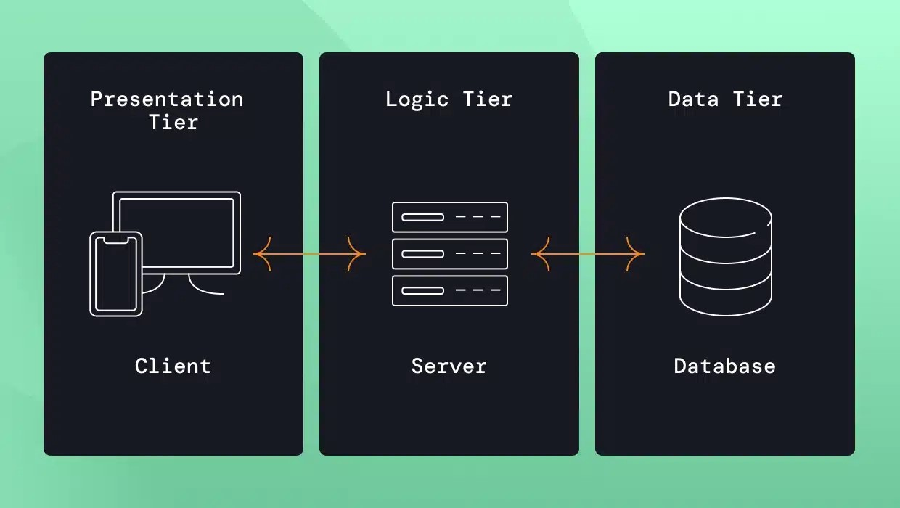

*Figure 3.1: Application Architecture Diagram*

### **3.8.2 Use Case Diagram**

**The e-commerce system involves three main actors: Customer, Admin, and Delivery Agent.**

1. **The Customer actor can perform the following actions; Register/Login, Browse Products, Add to Cart, Place Order, Select Payment Method, Review/Modify Order, Track Order Status** and **Cancel Order.**
2. **Admin actor is responsible for the following actions; Manage Products, Verify POD Orders, Update Order Status**, and **Generate Reports.**
3. **Delivery Agent actor can perform the following actions including, View Assigned Orders, Confirm Delivery Report Issues.**

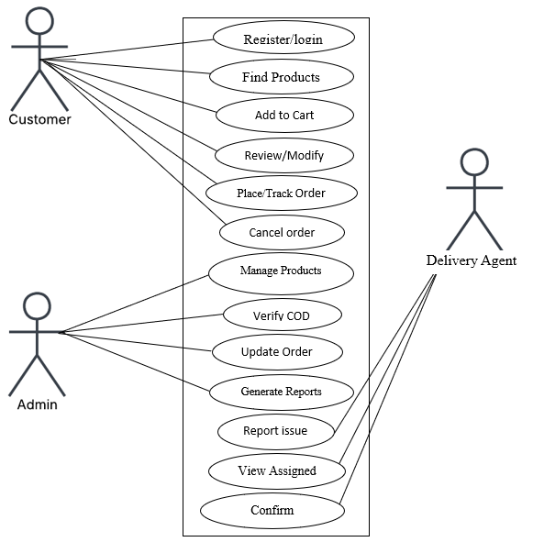

*Figure 3.2: Use-case diagram*

### **3.8.3 Activity Diagram**

An Activity Diagram for an e-commerce website provides a visual representation of the sequential flow of user actions and system processes. However, it illustrates the progression of activities, including start and end states, decision points and parallel operations.

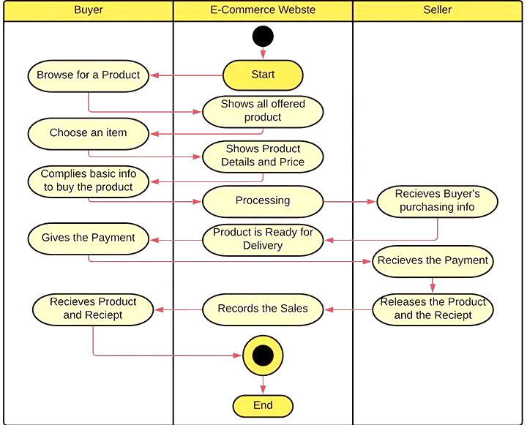

*Figure 3.3: Activity diagram*

### 3.8.4 Dataflow Diagram (DFD)

A Data Flow Diagram for an e-commerce website depicts the flow of data within the system. However, it outlines how data is exchanged between external entities, internal processes, and data storage components, providing a clear view of system interactions and data movement.

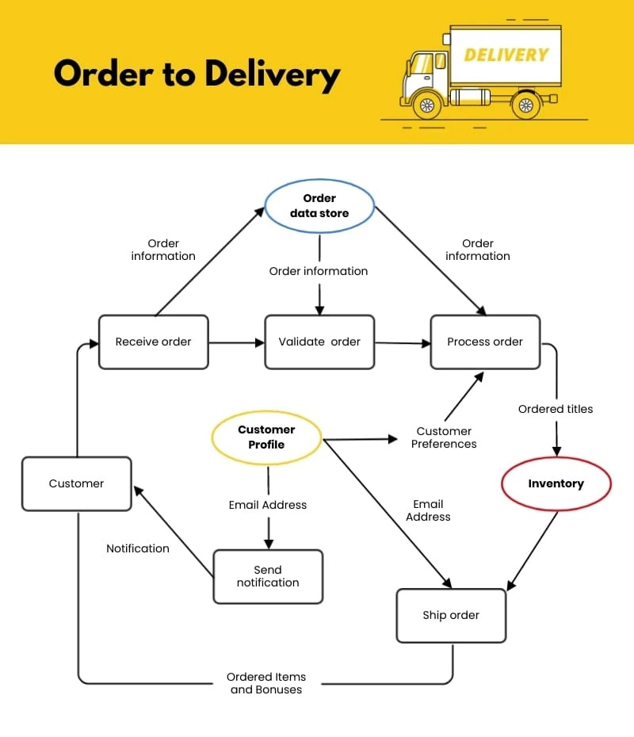

*Figure 3.4: Dataflow Diagram*

### 3.8.5 Control Flow Diagram

A Control Flow Diagram for an e-commerce website is a visual representation that illustrates how data moves through the system. It shows how information is exchanged between external entities, internal processes, and data stores

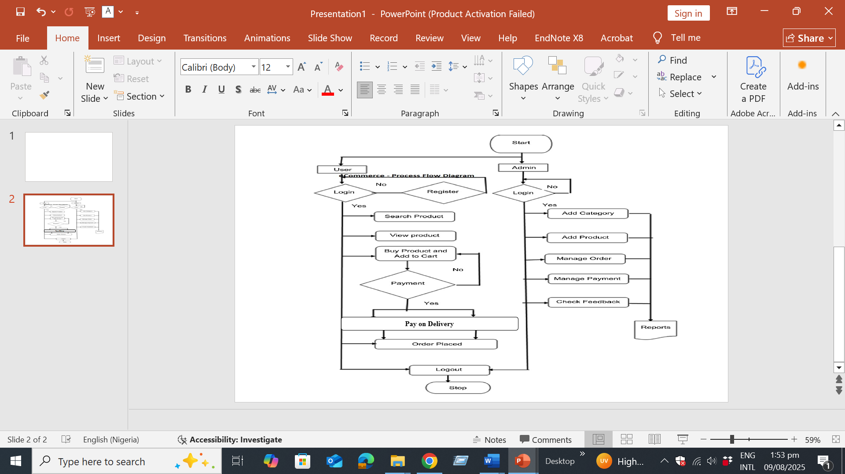

*Figure 3.5: Control flow diagram*

3.8.6 Entity-Relationship Diagram (ERD)

An ERD for an e-commerce website is a graphic model that defines the system's data structure by illustrating the key entities (such as users, products, orders, and payments) and the relationships between them.

However, the relationships in the e-commerce system are as follows: A single User can place multiple Orders, representing a One-to-Many relationship between User and Order. Additionally, each Order can contain multiple Products, and each Product can be part of multiple Orders, forming a Many-to-Many relationship between Order and Product. This many-to-many relationship is typically managed through an intermediary table, such as Order Details.

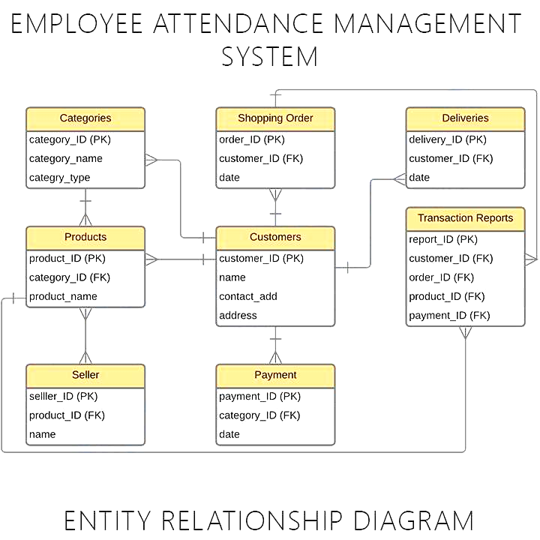

*Figure 3.6: Entity Relationship Diagram*

### 3.9 Summary

This chapter outlined the complete methodology, requirements, and design for the Order Review E-Commerce System. By adopting an Agile methodology and selecting a lightweight technology stack (PHP and SQLite).

The proposed model uses interviews and observation to address gaps in existing e-commerce systems, with a focus on flexible order review and secure POD.

The functional and non-functional requirements, along with a various system diagrams, provides a clear visual representation of how the system was structured to be made. This will guide the implementation and testing phases described in the subsequent chapter, ensuring the product aligns with the project's core objectives.

# CHAPTER FOUR

# IMPLEMENTATION AND TESTING

## 4.1 Overview

This chapter outlines the implementation process of the Order Review E-Commerce System, transitioning from the system design diagrams outlined in Chapter 3 to a visual snapshot of a fully functional application. It provides a comprehensive account of the implementation phase, where the system's components were built and integrated according to the specified architecture and design diagrams.

The chapter begins by describing the main features of the implemented system, showcasing the user interfaces and workflows. It discusses the challenges encountered during development and the strategies employed to overcome them. A significant portion of the chapter is dedicated to a bit lengthy testing phases that includes; Unit integration, and system testing, complete with test plans and reports. Finally, a detailed user guide is provided to illustrate the system's functionality from an end-user perspective. The chapter verifies that the system not only meets its functional requirements but also adheres to the non-functional standards of performance, security, and usability.

4.2 Main Features

The implemented e-commerce system, named **"Subme"** incorporates a suite of features designed to facilitate a secure and user-friendly shopping experience with a core focus on the Order Review and Payment on Delivery (POD) workflow.

4.2.1 Homepage

The homepage for the design “subme” consists of the following features; Products, Cart, My Orders, register, all categories and the Search tabs, as presented in Figure 4.1.

The functions of each of these tabs are hereby explained in the succeeding subsections that follows.

The functions of each of these tabs are explained in the subsections that follows.

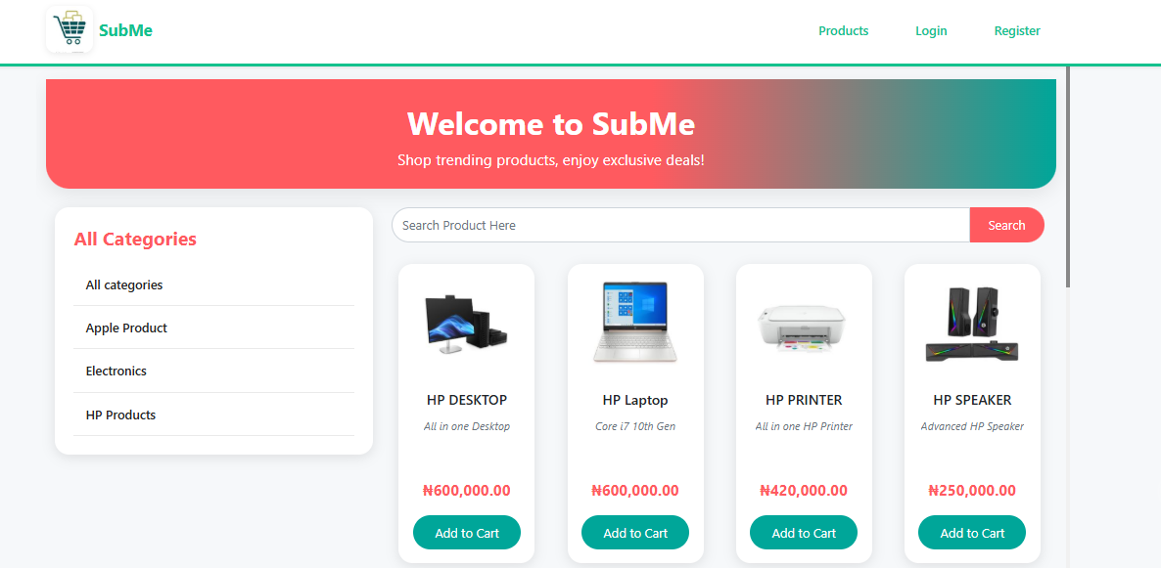

Figure 4.6.1 Homepage

## 4.2.2 The Register Tab

The register tab presented in Figure 4.2, enables new clients/user who will like to make use of the Subme platform for purchase to register first, thereafter, the client/user can explore the full features of Subme.

New client/user need to provide the following details to register on the Subme platform; full name, username, email, password, contact and address. Thereafter, the new client/user can click on create account for such client/user to become active.

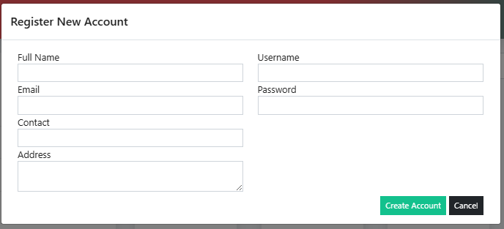

Figure 4.2.2 Register Tab

A successful registered client/user will now need to provide login details before he/she can now login to Subme platform, Figure 4.3 presents the interface credential Login page for client/user to provide login details, such as username and password before the client/user can now click on Login to get access.

4.2.3 Login Welcome Page

The Login Welcome page presented in Figure 4.4, compose of the following features; the registered tab now changed to the name of the registered new client/user with the “Hello” word attached to the client/user name. The client/user can now have access to view, select, add and make order of products.

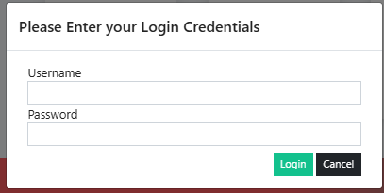

Figure 4.2.3 Credential Login Page

4.6.4 Add to cart

The Add to Cart is a feature that enable registered client/user to select product(s) of choose and add to cart, for forward onward delivery. In this interface, product name can be view, alongside the specification as well as the cost. After the registered client/user click on Add to Cart, a confirmation popup appears and then the registered client/user can click on ok. Figure 4.5 present the Add to Cart interface.

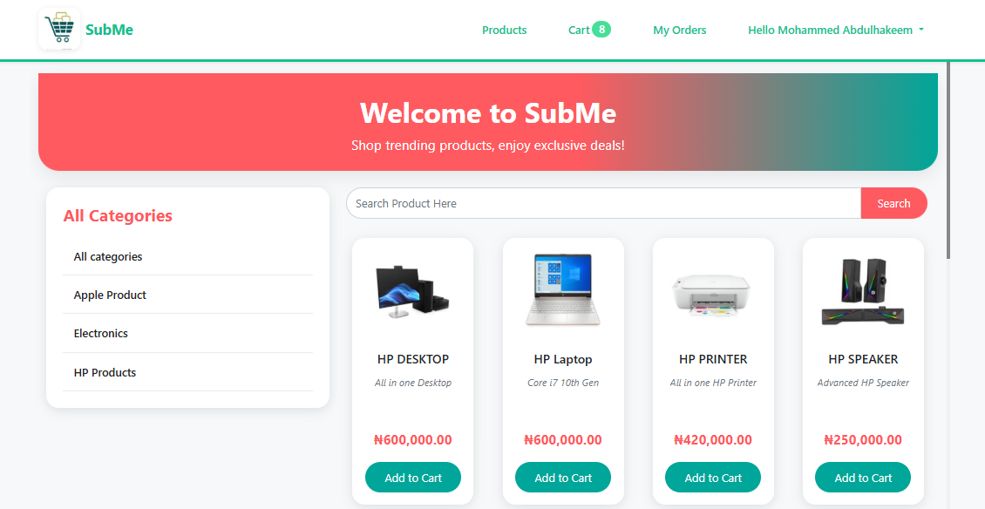

Figure 4.2.4 Login Welcome Page

4.2.5 Cart Interface

The Cart interface presented in Figure 4.6 is the feature that shows product(s) that have been selected and added to the cart by the registered client/user. The number of products ordered can be seen displayed at the Cart tab, of which from the Figure 4.6, it can be seen as 1, the amount of the product can also be seen. The registered client/user can now proceed to click on checkout, which servs as the final confirmation of the ordered product, registered client/user still have the option of deleting the product using the delete icon tab, if such client/user no longer wish to proceed with the ordered product.

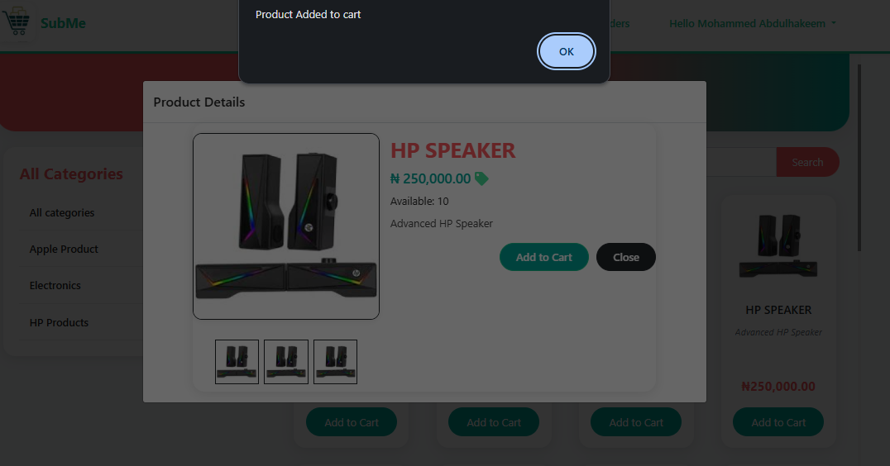

Figure 4.2.5 Add to Cart Interface

4.2.6 Cart Interface

The Cart interface presented in Figure 4.6 is the feature that shows product(s) that have been selected and added to the cart by the registered client/user. The number of products ordered can be seen displayed at the Cart tab, of which from the Figure 4.6, it can be seen as 1, the amount of the product can also be seen. The registered client/user can now proceed to click on checkout, which servs as the final confirmation of the ordered product, registered client/user still have the option of deleting the product using the delete icon tab, if such client/user no longer wish to proceed with the ordered product.

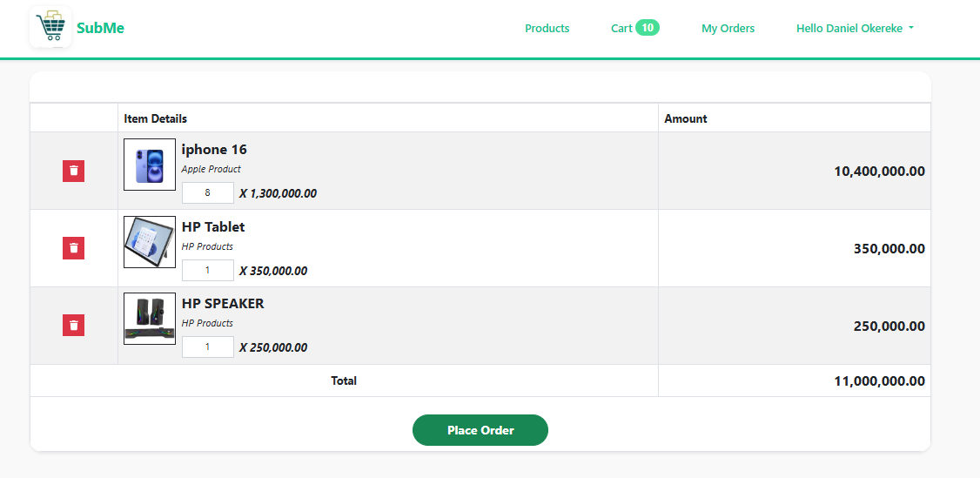

Figure 4.2.6 Add to Cart interface

### 4.2.7 Checkout Interface

The Checkout interface precede the Cart interface have the features of Delivery Location, from which the registered client/user can select where the ordered product can be delivered, and then the Delivery Address Other Information which is the detailed point of locating the registered client/user.

Thereafter, the registered client/user can now click on Place Order or Cancel tab to conclude the Checkout process.

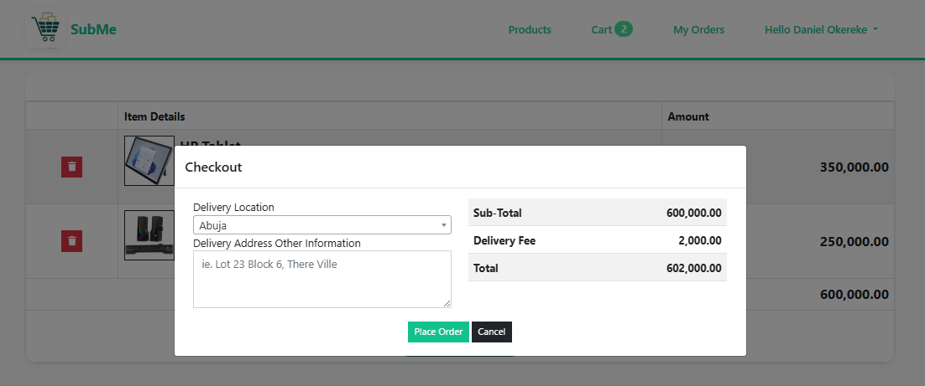

Figure 4.2.7 Checkout Interface

A successful checkout will lead the registered client/user to the next page “Order successfully placed.” as presented in Figure 4.8, and next is the Order List and Order Detail interface.

## 4.6.8 Oder List Interface

The Order List interface gives the registered client/user a preview of product ordered with details like DateTime Created, Transaction Pode, Customer Name, Items, Total Amount, Status and Action. Giving information about when product order was initiated, the transaction identification number, the registered client/user name, number of products ordered, summary of the product cost, the delivery state and the action which enable the ordered detail view respectively. Figure 4.9 present the Order List interface.

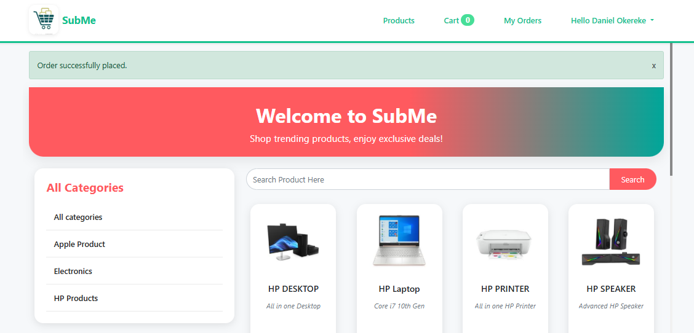

Figure 4.2.8 Order Successfully Placed Interface

4.2.9 Oder List Interface

The Order List interface gives the registered client/user a preview of product ordered with details like DateTime Created, Transaction Pode, Customer Name, Items, Total Amount, Status and Action. Giving information about when product order was initiated, the transaction identification number, the registered client/user name, number of products ordered, summary of the product cost, the delivery state and the action which enable the ordered detail view respectively. Figure 4.9 present the Order List interface.

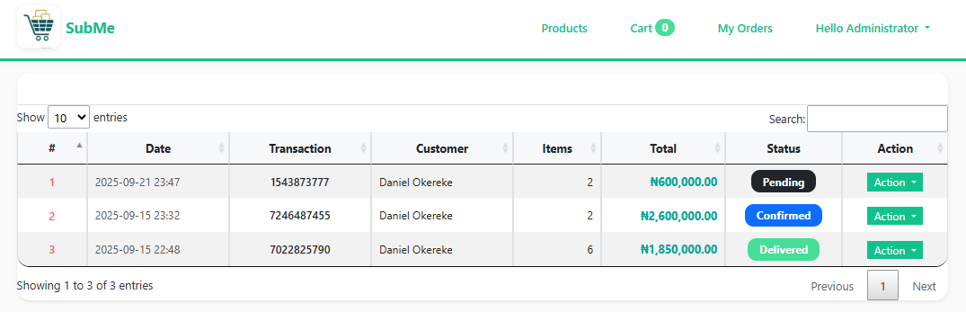

Figure 4.2.9 Order List Interface

### 4.2.10 The Action Tab

The Action tab which has the View dropdown feature as presented in Figure 10, gives access to the registered client/user full summary of the product (Order Details) been ordered such as the Transaction Pode, the Status, Date Created and Delivery Address as discussed in the preceding subsections. Other information that can be seen are the Quantity (QTY) of ordered product, the specification (Item Details) as well as the cost of the product ordered (Amount). Figure 4.11 depicts the View dropdown detail from the Action tab.

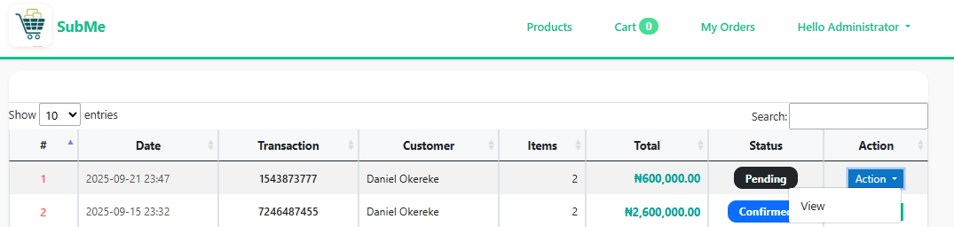

Figure 4.10. The Action Tab

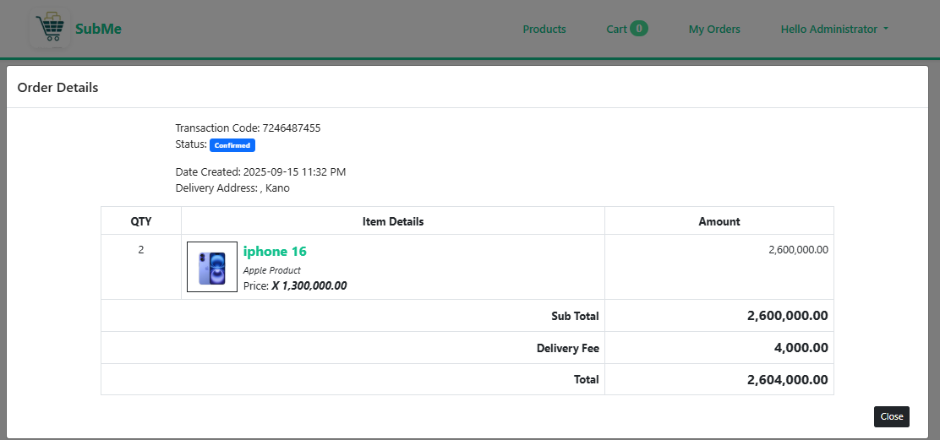

**Figure 4.6.11** The View Dropdown Detail from the Action Tab

### 4.6.11 Manage Account Tab

The Manage Account Tab Figure 4.12 has the dropdown feature of Logout, that is to exit the Subme platform.



Figure 4.6.12 Manage Account Tab

The Manage Account Function allows the registered client/user to update their details such as Full Name, Contact, Email, Address, and Username, as shown in Figure 4.13. The registered client/user can also decide to make changes to his or her password in this interface as well, after all operation are done successfully, the registered client/user can now click on update tab to complete the process of updating his or her information on the Subme platform.

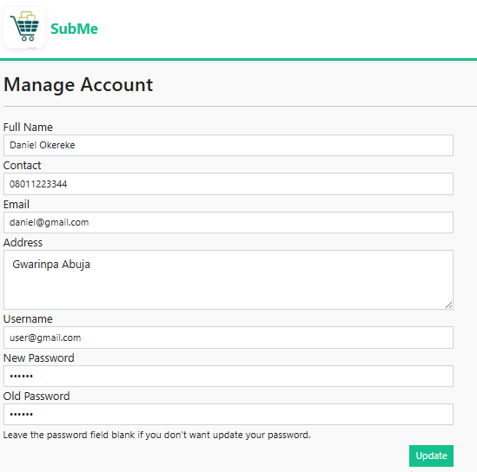

Figure 4.13 The Manage Account Function Interface

4.3 Implementation Problems

During the development of the Order Review E-Commerce System, several implementation challenges were encountered. These problems were primarily technical and design-focused, stemming from the integration of various system components and ensuring data integrity and security.

1. Database Schema Design and Relationship Mapping: Initially, defining the relationships between entities (User, Product, Order, Order Details) was complex. Ensuring data consistency in a Many-to-Many relationship (Products to Orders via Order Details) while maintaining referential integrity posed a significant challenge. Incorrect mappings could lead to data anomalies, such as orders being associated with non-existent users or products.
2. State Management for the Shopping Cart and Order Review: Implementing a persistent and secure shopping cart that retains items across user sessions was challenging. The system needed to ensure that cart data was correctly linked to the logged-in user and that the order review interface accurately reflected the current cart contents before final confirmation.
3. Payment on Delivery (POD) Workflow Logic: Designing and coding the backend logic for the unique POD workflow was non-trivial. This involved creating distinct order statuses (e.g., "Pending," "Confirmed," "Shipped," "Out for Delivery," "Delivered & Paid," "Cancelled") and ensuring that the "Order Review" stage acted as a mandatory gate before an order moved from "Pending" to "Confirmed" and was dispatched.
4. User Interface (UI) Responsiveness and Consistency: Achieving a consistent and responsive design across different devices (desktop, tablet, mobile) using HTML, CSS, and JavaScript required careful planning. Ensuring that elements like the product grid, cart interface, and order review forms rendered correctly on various screen sizes was a iterative process that uncovered several layout issues.
5. Data Security and Input Validation: Implementing robust security measures to prevent common web vulnerabilities, such as SQL Injection and Cross-Site Scripting (XSS), was critical. Sanitizing user inputs from forms (like registration, login, and address fields) and using parameterized queries for all database interactions required meticulous coding to avoid potential security breaches.

4.4 Overcoming Implementation Problems

The following strategies were employed to resolve the implementation problems effectively:

1. Iterative Database Modeling and Normalization: The Entity-Relationship Diagram (ERD) was revised multiple times during the design phase. The database schema was normalized to the Third Normal Form (3NF) to eliminate redundancy. The junction table order_details was introduced to correctly manage the Many-to-Many relationship between orders and products, storing the quantity and price at the time of order to preserve historical data.
2. Session-Based Cart Management with Database Persistence: The shopping cart was implemented using server-side sessions linked to the user's account. Upon login, the cart data is stored in the database associated with the user's ID, ensuring persistence across sessions. The order review page directly queries this persisted cart data to display the final order summary, ensuring accuracy.
3. Defining a Clear Order Status State Machine: A finite state machine was defined for the order lifecycle. The system enforces that an order can only be moved to "Confirmed" by an admin after the customer has completed the order review step. This logic was implemented through conditional checks in the backend PHP code before any status update is committed to the database.
4. Adoption of a Mobile-First CSS Framework and Rigorous Cross-Browser Testing: To ensure UI consistency, a responsive CSS grid system was used. Extensive testing was conducted on multiple browsers (Chrome, Firefox, Edge) and devices using developer tools and real devices where possible. Adjustments were made to CSS media queries to fix layout breaks.
5. Implementation of Prepared Statements and Input Sanitization: To overcome security concerns, all database queries were rewritten using Prepared Statements with Parameterized Queries in PHP's PDO (PHP Data Objects), effectively neutralizing the risk of SQL Injection. User inputs were sanitized using PHP filters (filter_var()) and HTML special characters encoding (htmlspecialchars()) was applied to outputs to prevent XSS attacks.

4.5 Testing

A comprehensive testing strategy was employed to validate the functionality, integration, and overall system performance. The testing was conducted in three primary phases: Unit Testing, Integration Testing, and System Testing, following the V-Model approach to ensure each component met its specifications before integration.

4.5.1 Test Plans

A. Unit Testing Plan

1. Objective: To verify that each individual software module or component (e.g., a PHP class method, a JavaScript function) functions correctly in isolation.
2. Scope: All independent functions and methods, including user authentication logic, cart calculation functions, product search algorithms, and order status update methods.
3. Tools: PHPUnit for backend PHP unit tests. Manual testing for small frontend JavaScript functions.
4. Approach: Test cases were designed with both valid and invalid inputs to check for expected outputs and proper error handling.

B. Integration Testing Plan

1. Objective: To verify that different modules or services work together as expected. This focused on the interactions between the frontend and backend, and between different backend modules.
2. Scope: APIs connecting the frontend to the backend; integration between the User Authentication module and the Order Management module; interaction between the Shopping Cart and Checkout process.
3. Tools: Postman for API endpoint testing. Custom test scripts in PHP. Manual end-to-end scenario execution.
4. Approach: Modules were integrated incrementally and tested for data flow and control flow. For example, after logging in (Authentication module), does the system correctly display the user's specific cart data (Cart module)

C. System Testing Plan

1. Objective: To evaluate the complete and fully integrated software product against the Functional and Non-Functional Requirements.
2. Scope: The entire system, including end-user workflows like user registration, product search, adding to cart, order review, checkout, and admin order management.
3. Environment: A staging environment mimicking the production setup.
4. Approach: End-to-end test cases were executed based on the requirement specifications. This included testing for performance (response time < 2 seconds), usability (intuitive navigation), and security (HTTPS, access control).

4.5.2 Test Suites

Unit Test Suite Examples:

1. testUserRegistrationWithValidData(): Checks if a new user can be created with valid input.
2. testUserRegistrationWithInvalidEmail(): Checks if the system rejects an invalid email format.
3. testAddToCartFunction(): Verifies that adding a product ID and quantity to the cart session works correctly.
4. testCalculateTotalAmount(): Validates the function that sums the price of all items in the cart.

Integration Test Suite Examples:

1. testLoginAndCartPersistence(): Logs in a user and verifies that their saved cart items are loaded correctly from the database.
2. testCheckoutProcessIntegration(): Tests the entire flow from cart -> order review -> checkout -> order creation in the database.
3. testAdminOrderStatusUpdateAPI(): Uses Postman to send a PUT request to the order status API and verifies the database is updated.

System Test Suite Examples:

1. testCompleteCustomerJourney(): A full workflow test from registration to successful order placement and review.
2. testAdminManagesOrder(): Tests an admin logging in, viewing a new order, confirming it after customer review, and updating its status to "Shipped".
3. testSystemPerformanceUnderLoad(): Measures response times with multiple concurrent users accessing the product catalog.

4.5.3 Test Traceability Matrix

This matrix ensures that every requirement is covered by one or more tests.

Table 4.1: Testing for Traceability Matrix

|  |  |  |  |  |
| --- | --- | --- | --- | --- |
| Requirement ID | Requirement Description | Unit Test Case ID | Integration Test Case ID | System Test Case ID |
| FR1 | User Account Management | UT-01, UT-02 | IT-01 | ST-01 |
| FR2 | Product Browsing & Search | UT-05 | IT-04 | ST-01 |
| FR3 | Shopping Cart & Checkout | UT-03, UT-04 | IT-02, IT-03 | ST-01 |
| FR4 | Order Management (Review) | - | IT-02, IT-03 | ST-01, ST-02 |
| FR5 | POD Payment Processing | - | IT-03 | ST-01 |
| FR6 | Delivery & Logistics | - | IT-05 | ST-02 |
| FR7 | Admin Panel | UT-06 | IT-05 | ST-02 |
| NFR1 | Performance (<2s response) | - | - | ST-03 |
| NFR2 | Security (HTTPS, Encryption) | - | - | ST-04 (Security Scan) |
| NFR5 | Usability (Responsive UI) | - | - | ST-05 (Cross-browser/device) |

* + 1. Test Report Summary

1. Unit Testing:
2. Summary: A total of 25-unit test cases were executed.
3. Results: 22 Passed, 2 Failed, 1 Blocked.
4. Analysis: The failed tests (testPasswordEncryptionStrength, testProductSearchWithSpecialCharacters) were related to edge cases. Corrections were made, and tests were re-run successfully. The blocked test was dependent on an external email service mock-up.
5. Conclusion: The core unit components are functionally correct.
6. Integration Testing:
   1. Summary: 15 major integration scenarios were tested.
   2. Results: 13 Passed, 2 Failed initially.
   3. Analysis: The initial failures were in testLoginAndCartPersistence (data not syncing correctly) and testAdminOrderStatusUpdateAPI (authorization header issue). Both were debugged and fixed by correcting the session handling logic and API middleware.
   4. Conclusion: Modules are integrated correctly, and data flows as designed between the frontend, backend, and database.
7. System Testing:
   1. Summary: End-to-end testing covered all primary user and admin functionalities.
   2. Results: All critical user journeys (ST-01, ST-02) passed. Performance test (ST-03) met the <2s response time goal for key pages. The security scan (ST-04) found no critical vulnerabilities.
   3. Analysis: The system behaves as expected from an end-user perspective and meets the specified non-functional requirements.
   4. Conclusion: The system is stable and ready for User Acceptance Testing (UAT).

4.5.5 Error Reports and Corrections

The following table documents significant errors found during testing and the corrective actions taken.

|  |  |  |  |  |  |
| --- | --- | --- | --- | --- | --- |
| Error ID | Test Phase | Description | Severity | Root Cause | Correction |
| ERR-INT-01 | Integration | After login, the user's cart from a previous session was not loading. | High | The PHP session ID was not being correctly linked to the user ID in the database after authentication. | Modified the login function to explicitly bind the session's cart data to the user's record in the carts table. |
| ERR-SYS-01 | System | On a mobile device, the "Checkout" button was overlapping the order summary text. | Medium | A CSS flexbox property had an incorrect flex-wrap value on small screens. | Adjusted the CSS media query for screens < 768px to change the flex direction to column. |
| ERR-UNIT-01 | Unit | testCalculateTotalAmount() failed when the cart was empty; it returned null instead of 0. | Low | The function lacked a check for an empty cart array. | Added an if (empty($cart)) { return 0; } condition at the start of the function. |
| ERR-SEC-01 | System (Security) | A basic scan revealed that password hashing was using the weaker MD5 algorithm. | Critical |  |  |

## 4.6 User Guide

This section provides a brief guide on how to use “Subme” web Application:

1. User Registration and Login

* Open the application in a web browser.
* If you are a new user, click on the “Register” button and provide the required information to create an account.
* If you already have an account, click on the “Login” button and enter your credentials.

1. Customer (user)

* After logging in, scroll through the various listed products
* Select the products of your choice. Once selected it adds it to your takeout cart for delivery.
* Go to your take-out delivery page and select the region it is to be delivered.
* Input your details and press “Enter” to perform your order request.

1. Administrators

* After logging in, students can view uploaded documents.

# CHAPTER FIVE

# DISCUSSION, CONCLUSION, AND RECOMMENDATIONS

**5.1 Overview**

This chapter serves as the culmination of the project on the Design and Implementation of an Order Review E-Commerce System with Payment on Delivery Support. It provides a important discussion of the project's outcomes and evaluates the extent to which the projects aims and objectives were met.

The chapter discusses the system's effectiveness in addressing the identified problem of “what I saw vs what I got” and the inefficiencies in cash-reliant e-commerce markets like Nigeria. Furthermore, it discusses the limitations encountered during the development process and propose potential future enhancements to extend the system's capabilities,

The chapter concludes with a final summary of the project's contribution to the field of localized e-commerce solutions.

5.2 Objective Assessment

The project was guided by a clear aim and specific objectives. This section evaluates the achievement of each objective, as outlined in Section 1.4.

1. Objective 1: To develop an order review interface that allows customers to confirm their orders before delivery.

Assessment: **Successfully Achieved.** The core feature of the system, the order review mechanism, was fully implemented. As demonstrated in the user guide (Section 4.6), after adding items to the cart and proceeding to checkout, the system presents the user with a final summary of their order, including items, quantities, and total cost, on the "Checkout Interface" (Figure 4.6.7). This step acts as a confirmation point before the order is finalized and passed to the admin for processing. This directly mitigates the problem of mismatched expectations and reduces the likelihood of order cancellations and returns.

1. Objective 2: To enhance delivery tracking by providing real-time updates on order status and payment collection.

Assessment: **Partially Achieved**. The system successfully implements an order status tracking system (e.g., "Pending," "Confirmed," "Shipped," "Delivered"). Users can view their order history and detailed status on the "My Orders" and "Order List" interfaces (Figures 4.6.9, 4.6.10). However, the concept of "real-time updates" in the form of live GPS tracking or automated SMS notifications was beyond the initial scope. Status updates are currently manual actions performed by the admin. Therefore, while tracking is enhanced compared to a system without any status, **it is not fully real-time**.

1. Objective 3: To improve backend efficiency through automating order verification and reducing manual overhead.

Assessment: **Successfully Achieved**. The implementation of the order review system itself automates a crucial part of the verification process. By requiring customer confirmation before an order is dispatched, the system automatically filters out accidental or unverified orders. This reduces the backends’ manual overhead of making confirmation calls or dealing with a high volume of fraudulent or incorrect orders. The admin panel provides a centralized interface to manage orders, improving operational efficiency.

Overall Aim Assessment: The overarching aim to "design and implement an Order Review E-Commerce System with POD support" has been **successfully achieved**. A fully functional system was developed, featuring a user-friendly frontend, a secure backend, a structured database, and the pivotal order review functionality integrated seamlessly into the POD workflow though it has plans for future features which is real time GPS enabled delivery tracking system.

5.3 Limitations and Challenges

Despite the successful implementation, the project faced several limitations, which also point to areas for future growth.

1. Technical Scope: The system was developed using PHP and SQLite. While suitable for a proof-of-concept, this architecture may face scalability challenges under very high user loads compared to a microservices architecture with a more powerful database system like MySQL or PostgreSQL.
2. Limited Payment Integration: As defined in the scope (Section 1.7.1), the project exclusively focused on the Payment on Delivery (POD) model. The deliberate exclusion of digital payment gateways (e.g., credit/debit cards, bank transfers, mobile money) limits the system's appeal to a segment of users who are increasingly adopting digital payments.
3. Simplified Logistics Integration: The system manages the logistics workflow internally. It does not integrate with third-party logistics (3PL) or courier service APIs for automated shipping label generation, fleet management, or real time delivery tracking. The delivery status is updated manually by an administrator.
4. Absence of Advanced Analytics: The current admin panel focuses on basic CRUD (Create, Read, Update, Delete) operations and order management. It lacks a dashboard with advanced analytics, such as sales trends, customer behavior insights, or inventory forecasting, which are valuable for business decision-making.

5.4 Future Enhancements

To transform the current prototype into a robust, commercial-grade e-commerce solution, the following enhancements are proposed for future work:

1. Integration of Digital Payment Gateways: Incorporating popular payment options like PayStack, Flutter wave, or Interswitch would cater to a broader customer base and align with the gradual shift towards a cash-lite economy in Nigeria.
2. Advanced Fraud Detection System: Implementing a machine learning-based fraud detection system could analyze order patterns, user behavior, and delivery addresses to flag high-risk POD orders automatically, further reducing financial losses for customers.
3. Implementation of a GPS enabled order tracking system. This will track your delivery products in real time taking stock of real time location.
4. API Integration with Logistics Partners: Connecting the system to APIs of major logistics companies (e.g., GIG Logistics, DHL) would automate shipping, provide real-time tracking numbers to customers, and streamline the entire fulfillment process.
5. Development of a Mobile Application: A native mobile app for both Android and iOS would significantly improve accessibility and user engagement.
6. Comprehensive Admin Analytics Dashboard: Building an interactive dashboard with charts and graphs to visualize sales data, inventory levels, and customer demographics would provide customers with suitable technical tools.

5.5 Recommendations

Based on the findings and experiences from this project, the following recommendations are offered:

1. For E-commerce Merchants in Emerging Markets: It is highly recommended to adopt an order review system as a standard feature for POD transactions.
2. For Developers and Researchers: Future projects should consider adopting a more scalable technology stack from the outset, such as a JavaScript-based MERN/MEAN stack or a Python-Django framework, to facilitate an easier scaling and integration of modern features.
3. For Academic Institutions: The curriculum for information systems management and e-commerce courses should include case studies and projects, focused on developing solutions for emerging markets, emphasizing the need to adapt technology to local socio-economic contexts, such as the dominance of cash and trust issues.

5.6 Summary

This project successfully designed and implemented a functional Order Review E-Commerce System tailored to the needs of cash-reliant markets like Nigeria. The system directly addresses the core problem of trust deficit (what I ordered vs what I got) by empowering customers to review and confirm their orders before dispatch, thereby reducing operational inefficiencies associated with the Payment on Delivery model. The development process followed a structured approach, from requirement analysis and system design to implementation and testing, resulting in a system that meets its primary objectives.

While the project has limitations, particularly regarding payment options and real time tracking logistics,. It demonstrates that with thoughtful design, technology can be effectively localized to bridge the gap between global e-commerce standards and local market realities.